Assignment 7.2

Name : Y Vasudev

Batch : DA with R , Excel and Tableau

1. Write a program to create **barplots** for all the categorical columns in **mtcars**.

> colnames(mtcars)

[1] "mpg" "cyl" "disp" "hp" "drat" "wt" "qsec" "vs" "am" "gear" "carb"

> par(mfrow=c(3,4))

> par(pin=c(1, 1))

>

> for(i in 1:ncol(mtcars)) {

+ boxplot((mtcars[,i]), main=names(mtcars)[i])

+ }

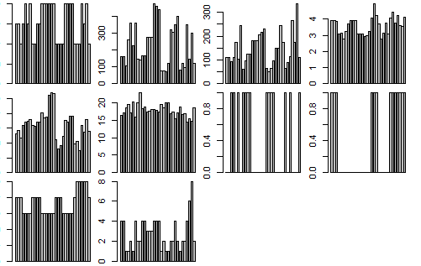

2. Create a **scatterplot** matrix by gear types in **mtcars** dataset.

> scatter.smooth(mtcars$gear)

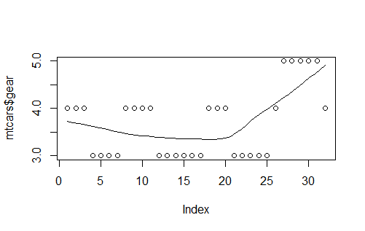

3. Write a program to create a **plot density** by class variable.

x <- mtcars[,c(1,3,4,5,6,7)]

y <- as.factor(mtcars[,2])

scales <- list(x=list(relation="free"), y=list(relation="free"))

featureplot(x=x, y=y, plot="density", scales=scales)